EXPERIMENT:6: Demonstrate virtualization by Installing Type-2 Hypervisor in your device, create and configure VM image with a Host Operating system (Either Windows/Linux).

STEP:1: WE NEED TO GO FOR THE ISO GUEST OPERATING SYSTEMS.

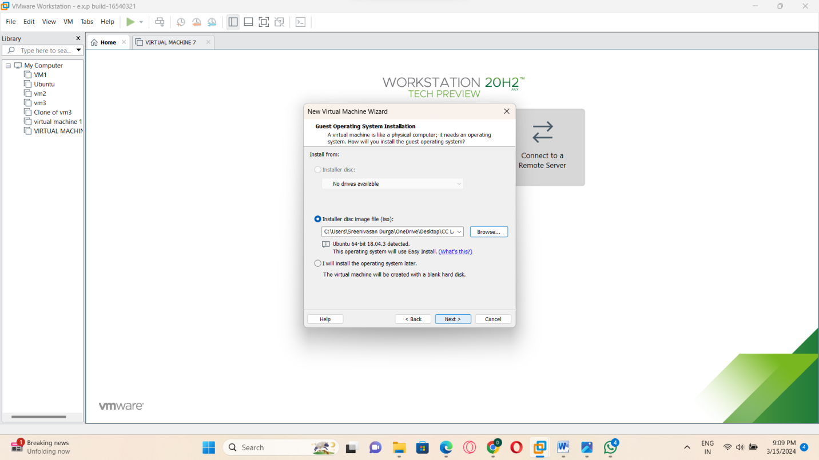

STEP:2: AND ALSO TYPE THE RESPECTIVE DETAILS BELOW:

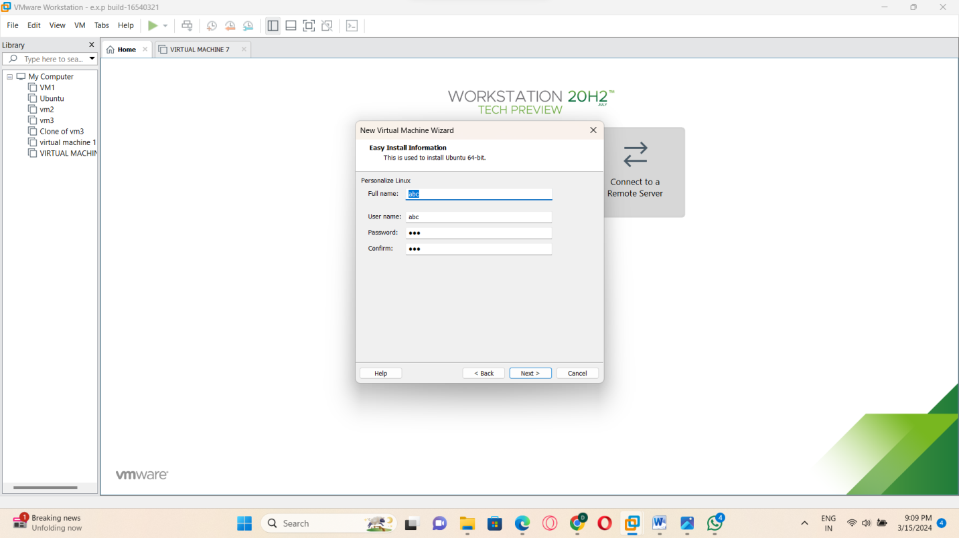

STEP:3: THEN NAME THE REAL TIME MACHINE

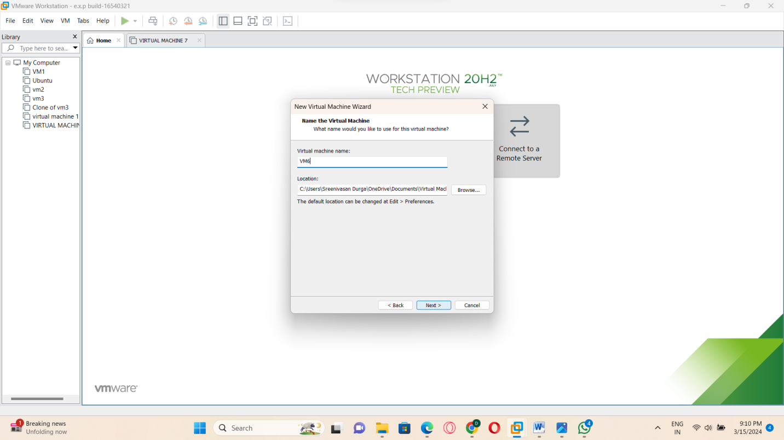

STEP:4; AND THEN SPECIFY THE HARD DISK:

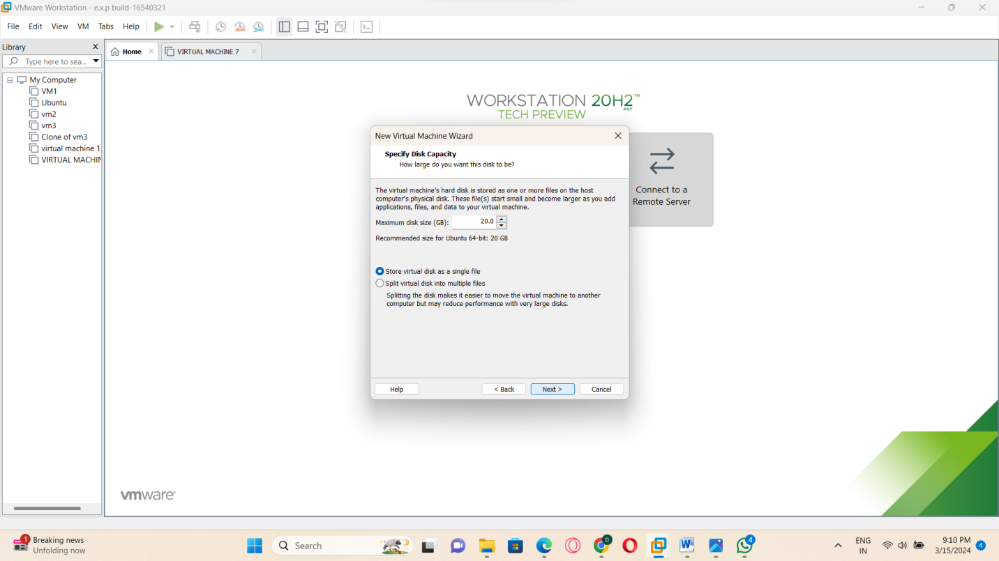

STEP:5:: NOW READY TO CREATE THE VIRTUAL MACHINE:

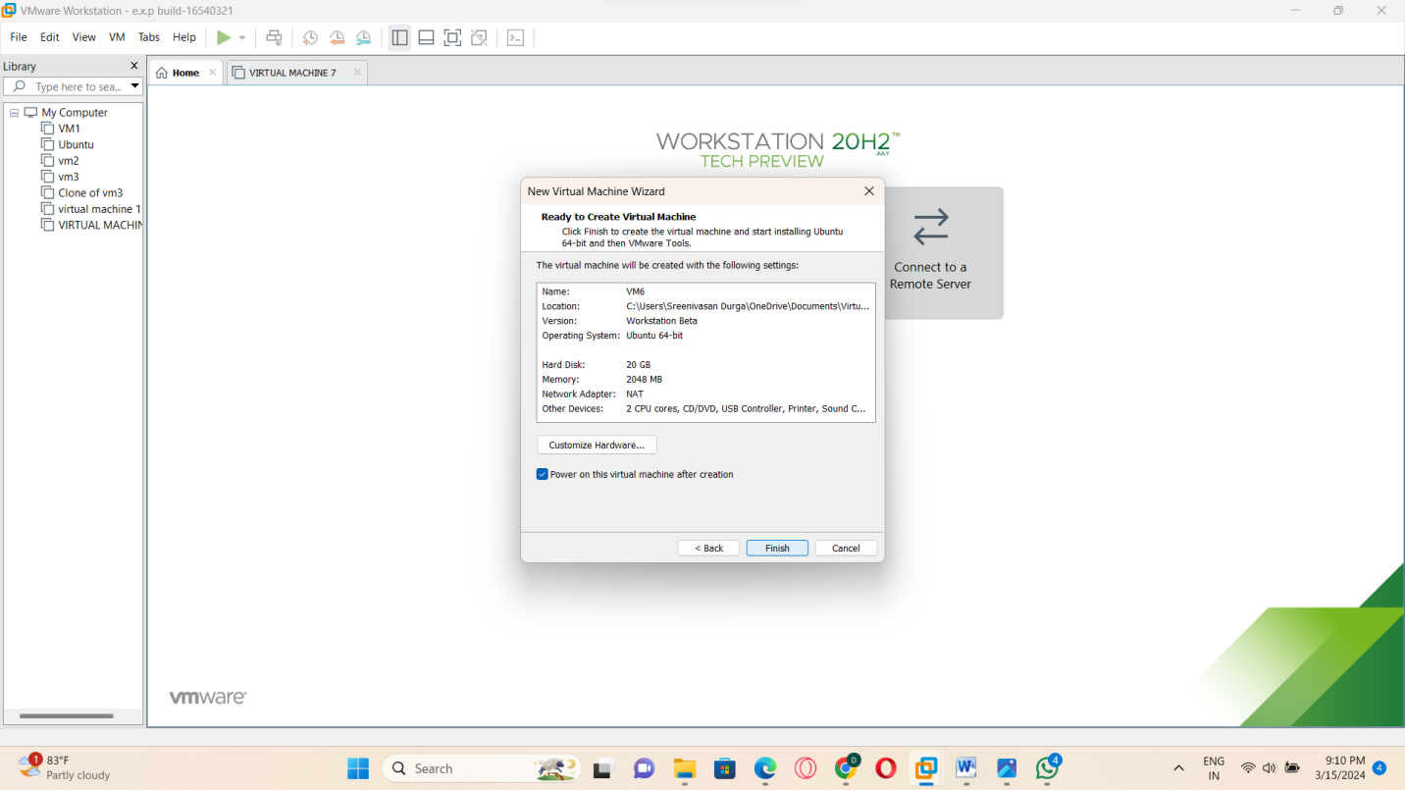

STEP:6: AND TURN ON THE POWER AS FOLLOWS: THE OUPUT WILLL BE GENERATED:

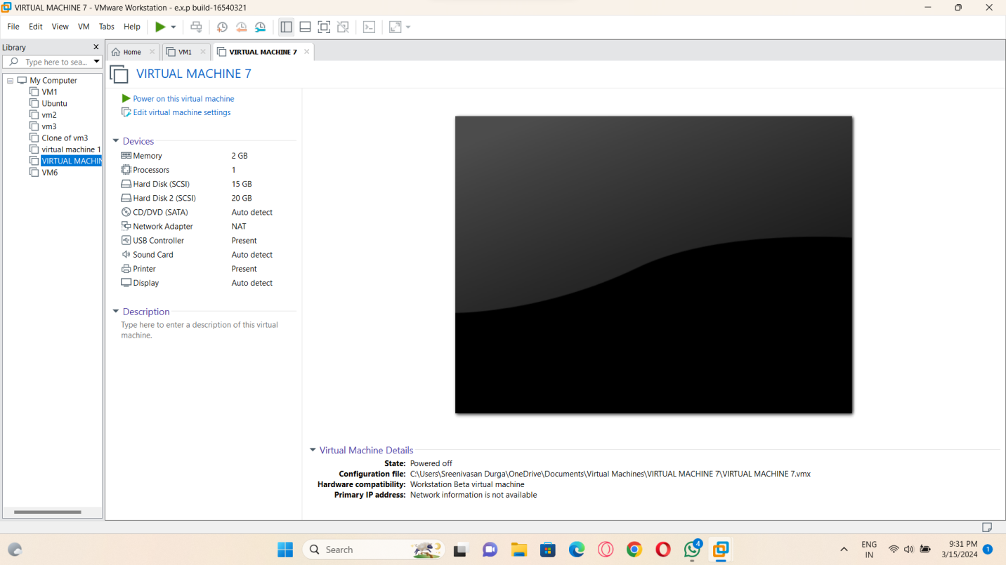

RESULT: THUS THE PROGRAM FOR VM-WARE HAS BEEN EXCEUTED SUCCESSFULLY.